Lab 1 Report
Student Name: LEI JIANG
Student ID: 110195911
Date: May 6, 2026

📋 1. SEEDVM Setup (Task 1) I have successfully set up the SEED Ubuntu 20.04 virtual machine on AWS cloud and connected to it via VNC Viewer.
Proof Screenshot:
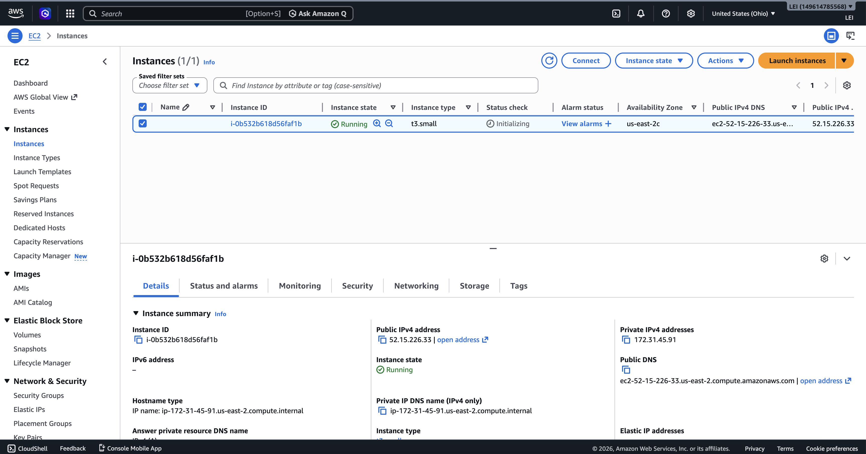
Marked elements:
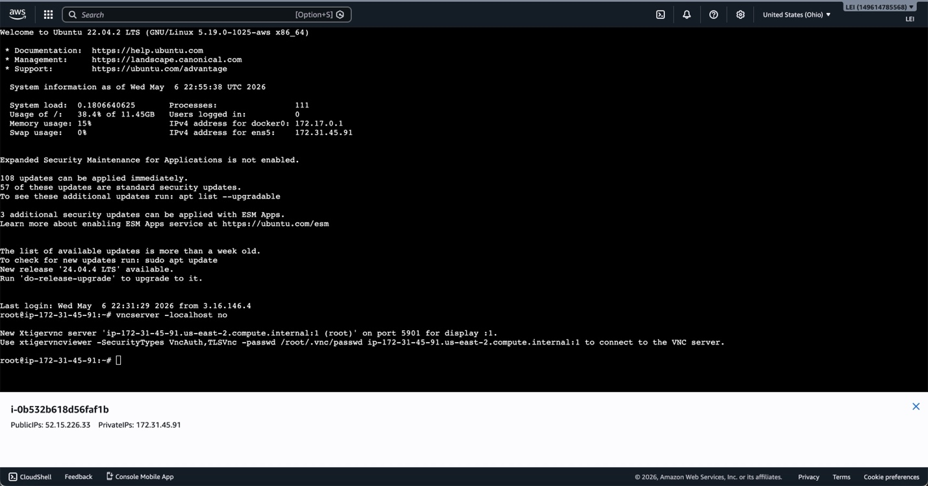
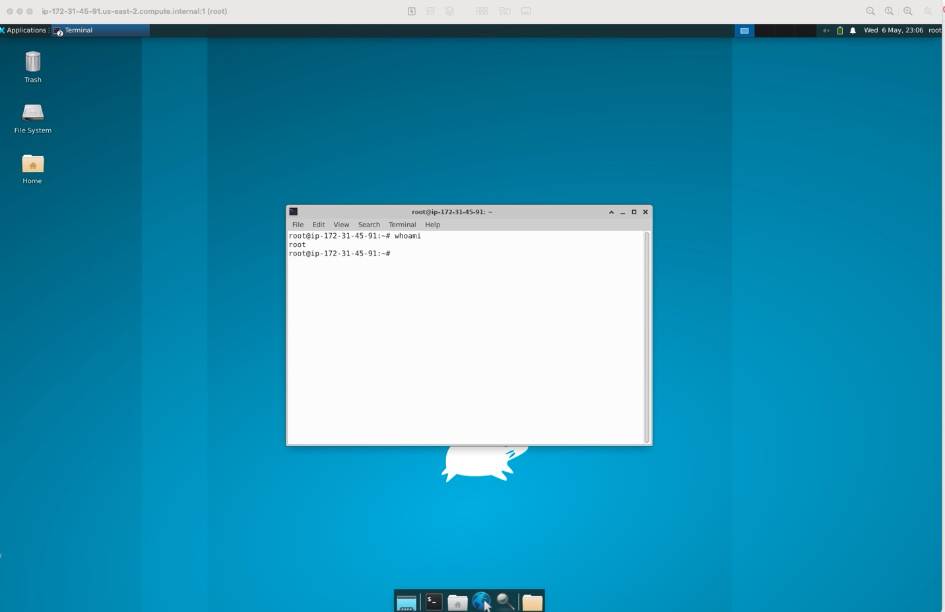

🔍 2. Sniffing HTTP Packet (Task 2)
a. Protocols in the Packet List In the packet list, the Protocol column contains many different protocols. I identified at least the following 4 protocols: DNS, TCP, VNC, HTTP.
Screenshot:
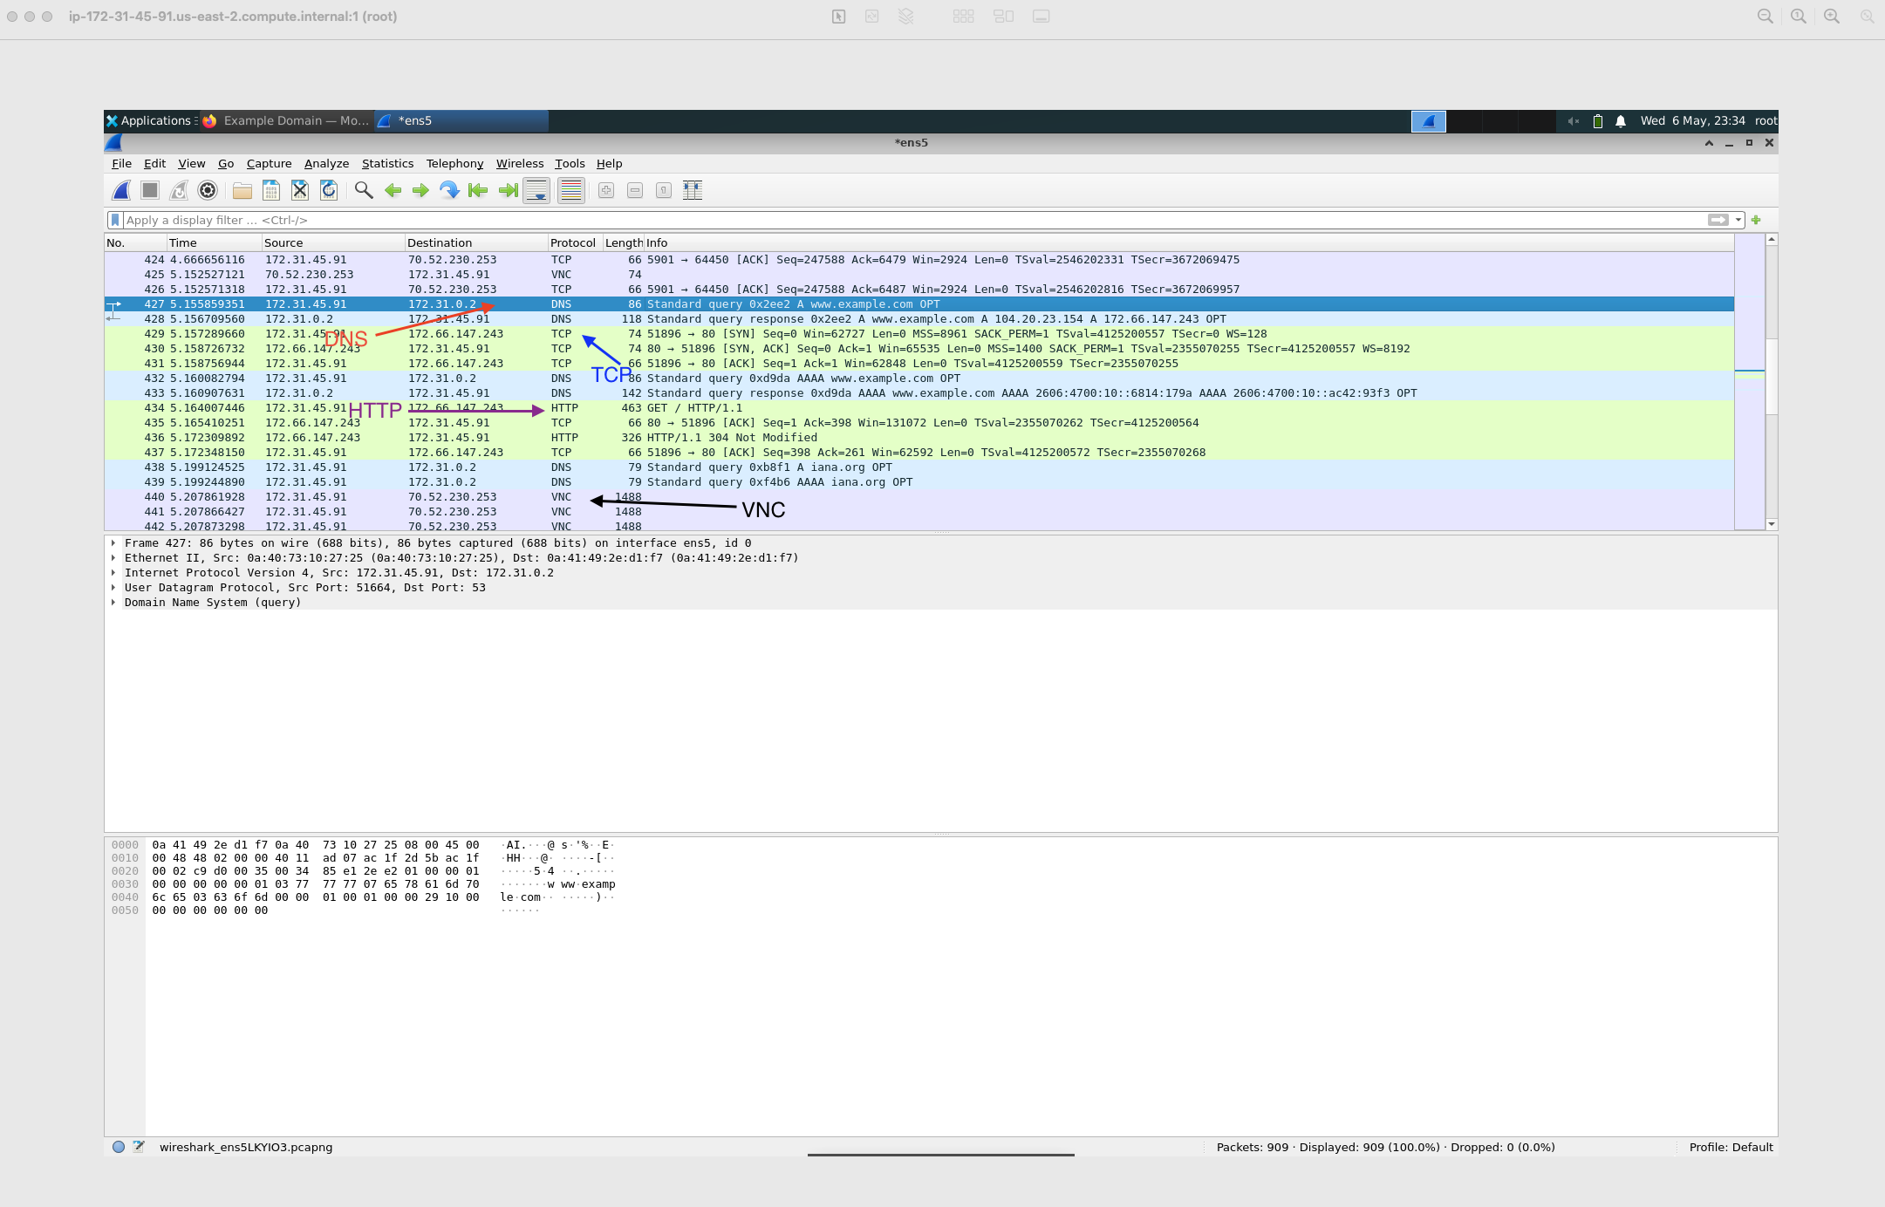

b. Four Layers of a DNS Packet I opened one DNS packet (Packet 427). As discussed in class, it contains the following four layers:
- Link Layer: Ethernet II
- Network Layer: Internet Protocol Version 4
- Transport Layer: User Datagram Protocol
- Application Layer: Domain Name System (query)
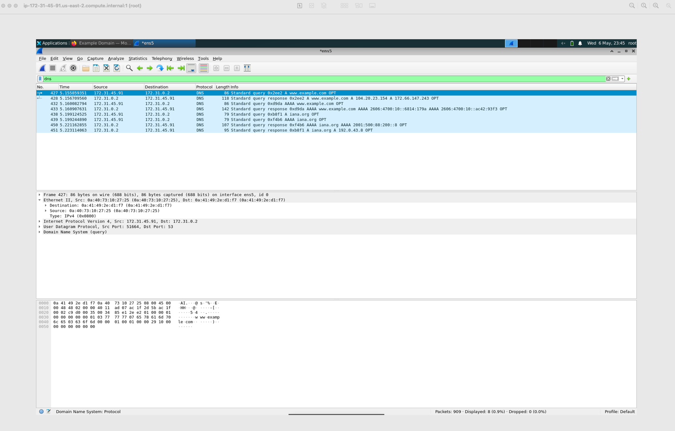
Screenshots (4 separate images):
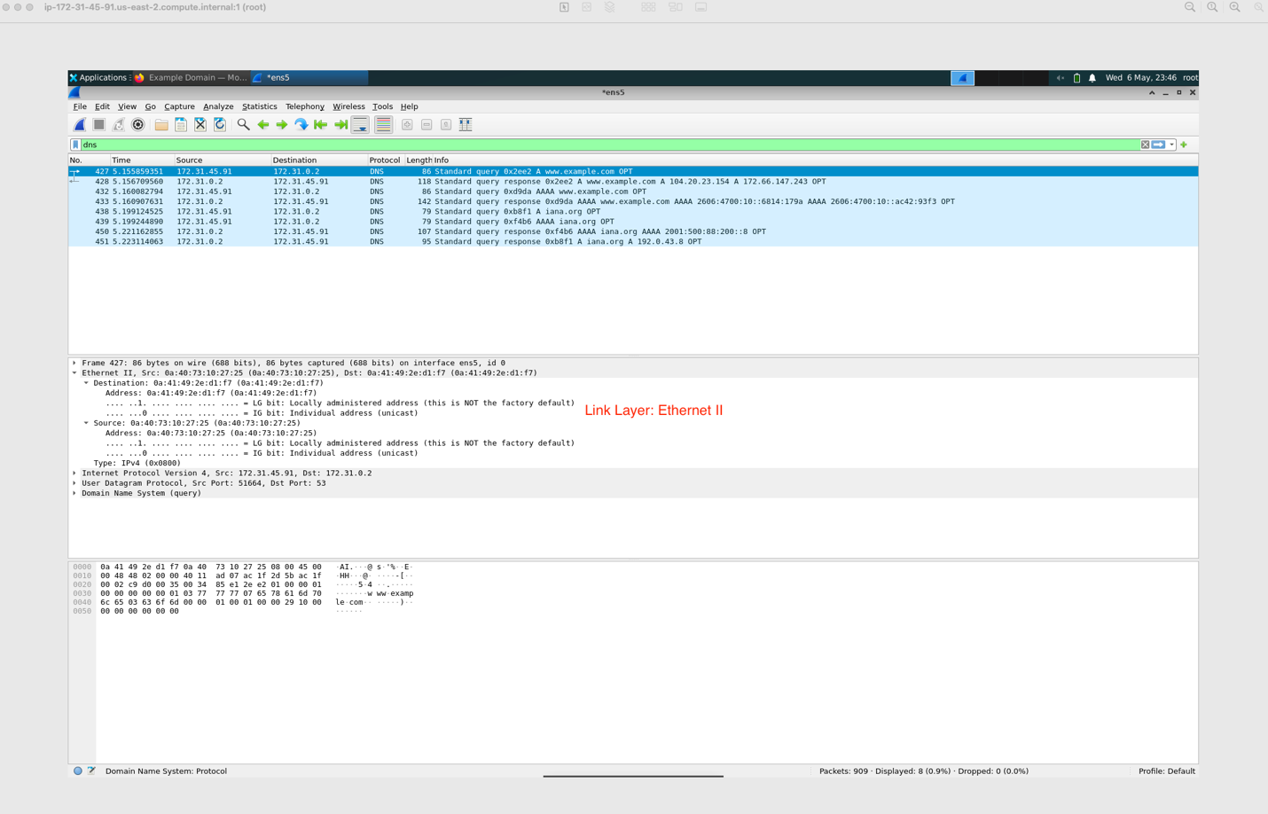
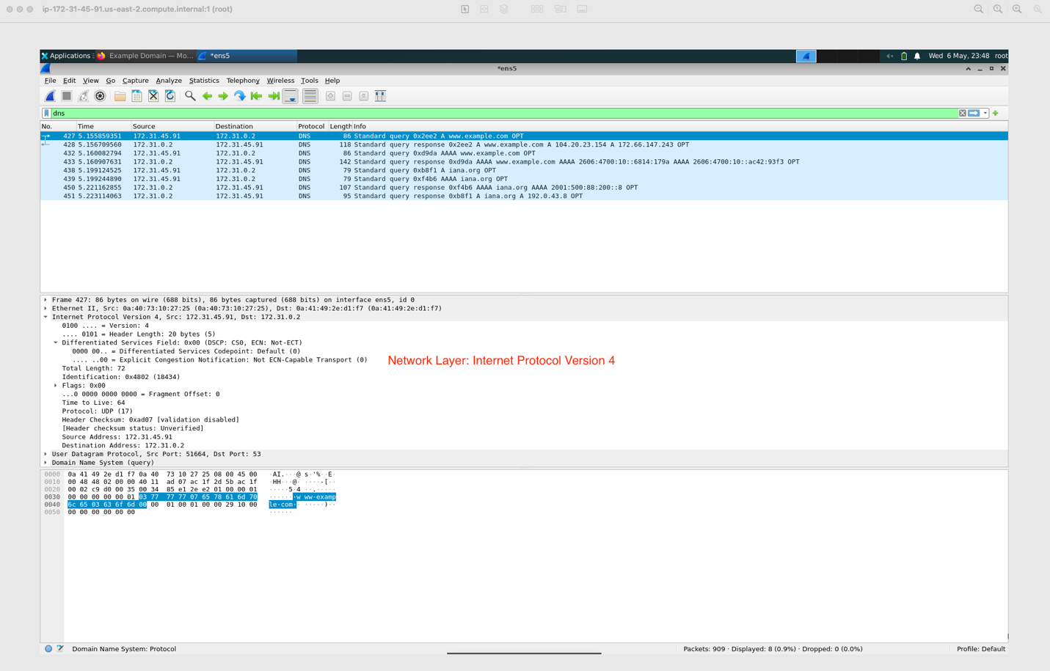
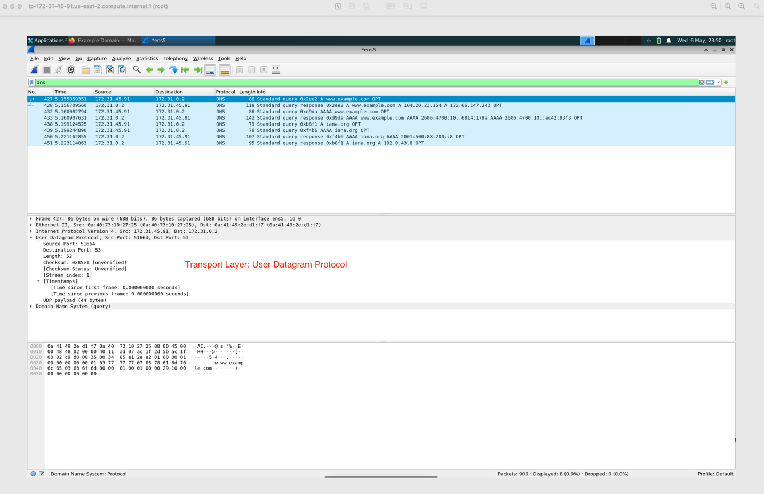
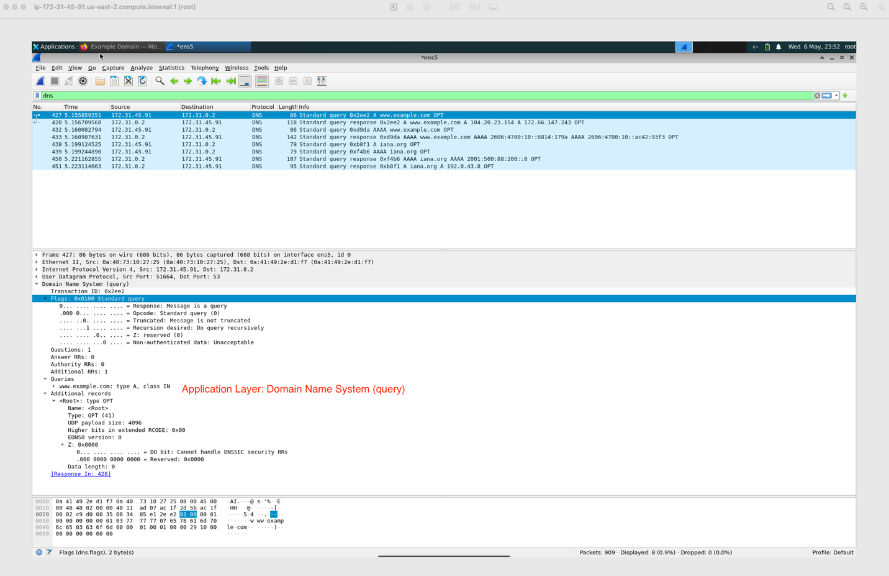

c. DNS Query Packet and Response Packet Before the browser sends the HTTP request, it first issues a DNS query to resolve the IP address of the website.
- DNS Query Packet (Packet 427): Contains [Response In: 428].
- DNS Response Packet (Packet 428): The answer is under Answers section.
The IP address of www.example.com is: 104.20.23.154 and 172.66.147.243
Screenshots:
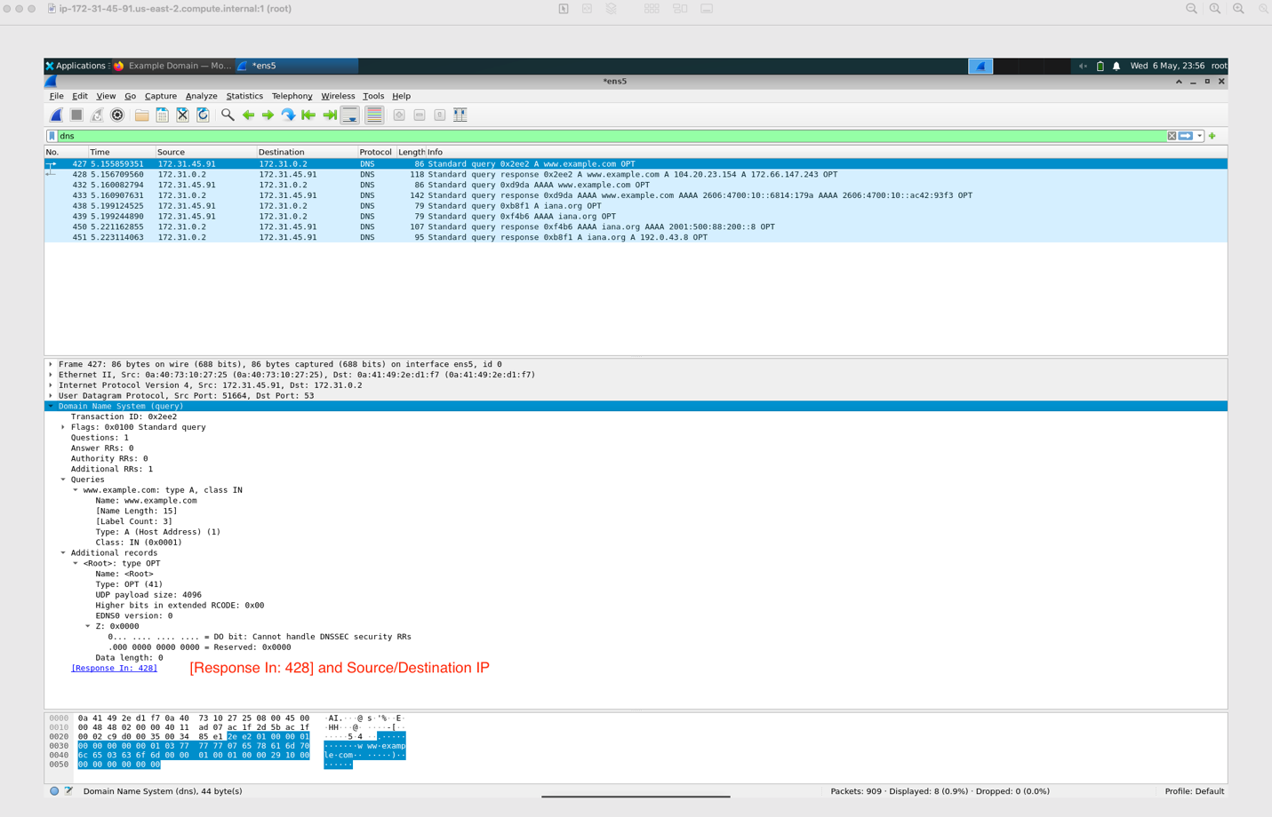
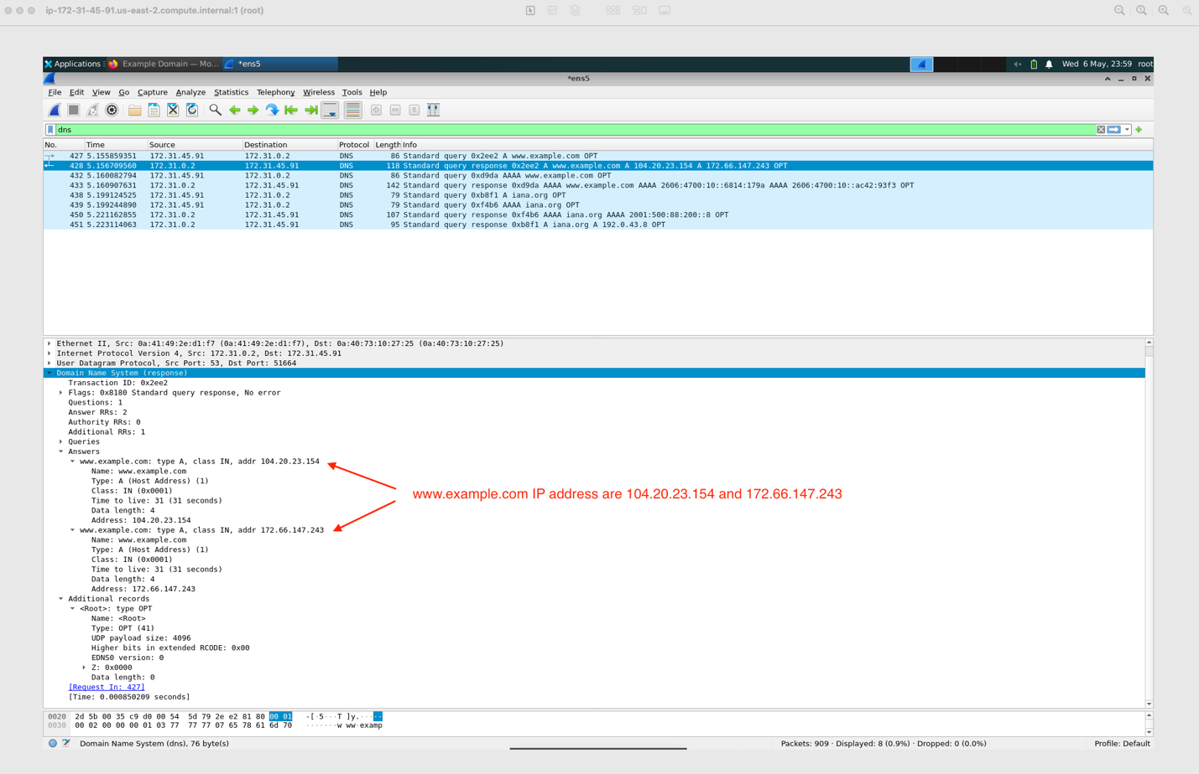

d. Source IP and Destination IP of the DNS Query Packet
- Source IP (my machine / virtual machine IP): 172.31.45.91
- Destination IP (DNS server IP): 172.31.0.2
Screenshot:
